**Worksheet-1.3**

**Student Name:-** Pushpraj Roy **UID:-** 20BCS9866

**Branch:-** BE- CSE **Section/Group:-** WM_617 “A”

**Subjetct Code:-** 20CSP-317 **Semester:-** 5th

**Subject Name:-** Machine Learning Lab

* **Aim/Overview of the practical: -**

To implement the Linear Regression on any data set.

**Linear Regression** – Finding a straight line of best fit through the data .This works well when the true underlying function is linear.

A linear model makes a "hypothesis" about the true nature of the underlying function - that it is linear. We express this hypothesis in the univariate case as

hθ(x)=ax+b

Our simple example above was an example of "univariate regression" - i.e. just one variable (or "feature") - number of hours studied. Below we will have more than one feature ("multivariate regression") which is given by

hθ(x)=a⊤X

Here a is a vector of learned parameters, and X is the "design matrix" with all the data points. In this formulation the intercept term has been added to the design matrix as the first column (of all ones).

* **Code/ Output:-**

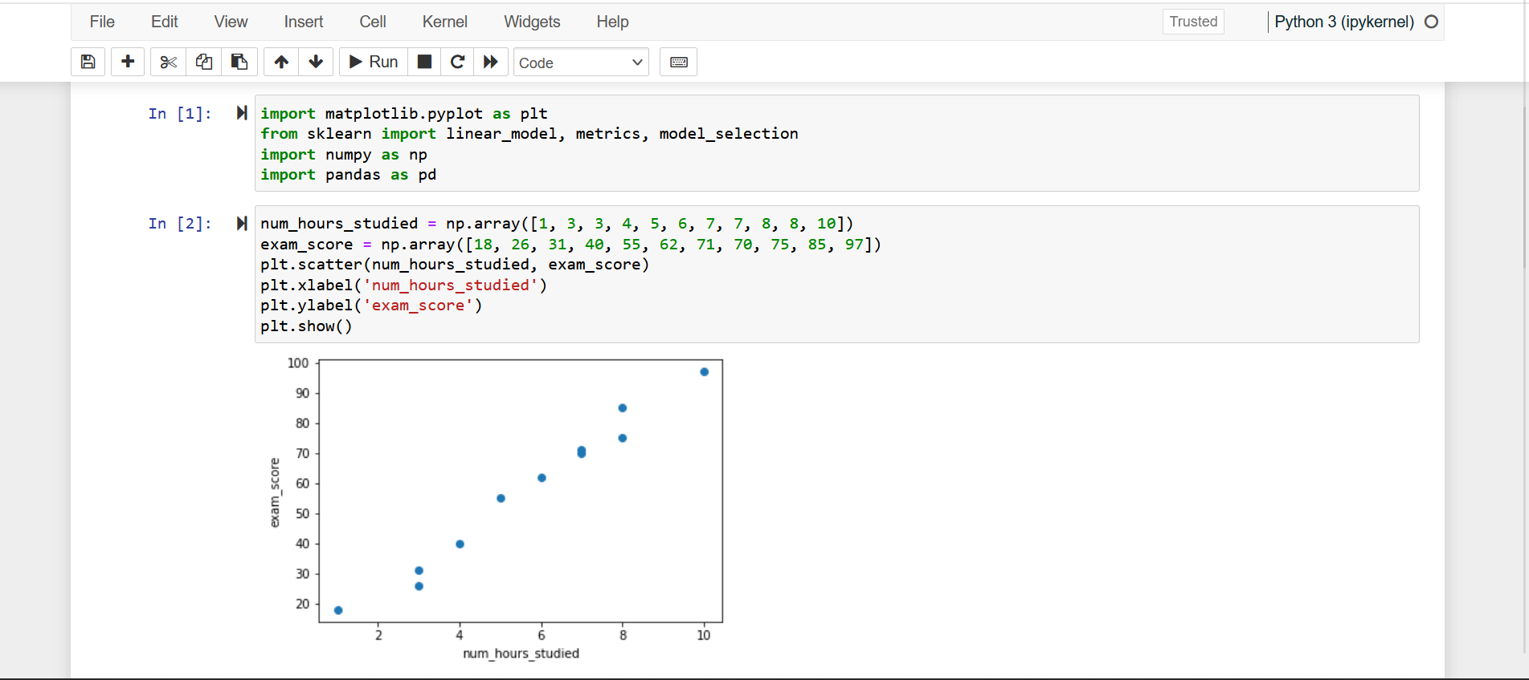

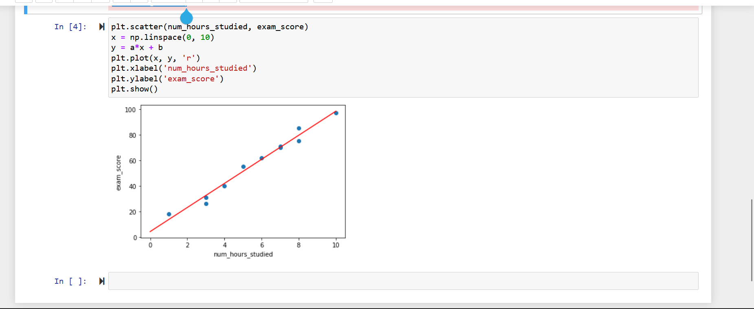

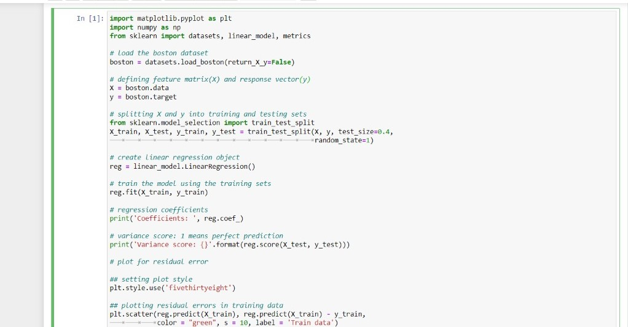

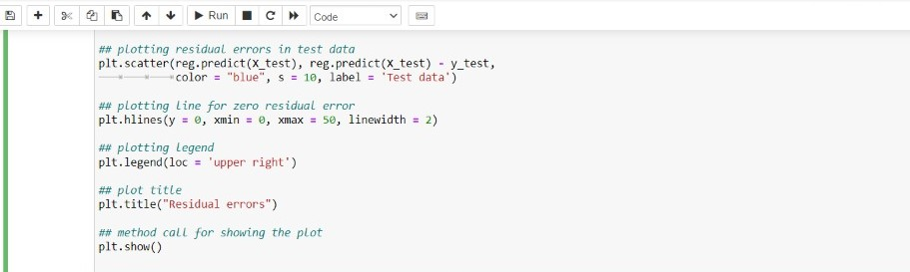

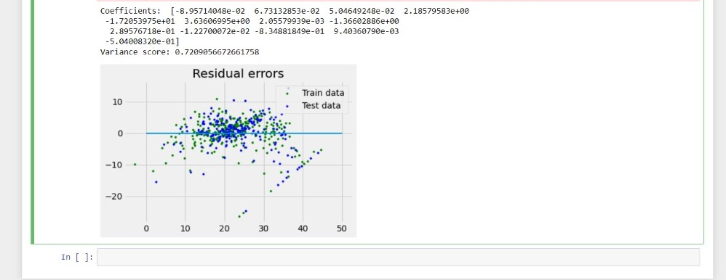

* **Learning outcomes (What I have learnt):**

1. We learned about data analysis and data handling in python.
2. We learned about various basic functions and libraries required for data analysis using python.
3. We learned graphically analyze data functions of matplotlib library in python.
4. We learned about linear regression and its implementation.

**Evaluation Grid (To be created as per the SOP and Assessment guidelines by the faculty):**

|  |  |  |  |
| --- | --- | --- | --- |
| Sr. No. | Parameters | Marks Obtained | Maximum Marks |
| 1. |  |  |  |
| 2. |  |  |  |
| 3. |  |  |  |
|  |  |  |  |